Julia Teitelbaum

jteitelb

**Design overview**

# Project Title

Potions and Proportions

# Project Design

## Main Purpose:

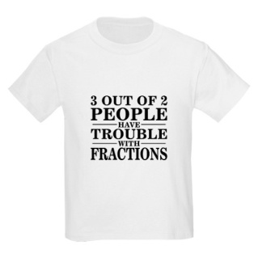Overall, U.S. students have a poor understanding of rational numbers. Teachers too, find that rational numbers, specifically fractions, are a difficult subject to teach. Not understanding fractions and proportions inhibits a student’s further progress in mathematics and their decision making ability in real-world situations.

The purpose of this project is to create a game that will introduce elementary school students to fraction concepts in an engaging and effective way. The game will develop students’ conceptual understanding of fractions through in a virtual potion-making game.

# Modules

The modules in this program are:

glop, measures, cauldron, recipes, and bottles

The module glop is the central program module. It handles user input in the form of keys pressed and mouse clicks. The module glop uses functions and objects from all of the other modules to help it draw the canvas and create objects. The functions in glop are:

leftMousePressed, leftMouseClickAndDrag, leftMouseReleased, keyPressed, init, getNewRecipe, find, drawScene, redraw, drawIngredientsShelf, drawMeasuresShelf, drawRecipeBook, drawCounter, createMeasuringCups, drawMeasuringCups, drawBottles, drawRecipe, RBGtoHex, and run

leftMousePressed uses information about the location of a single left mouse press to determine whether the user was clicking on an ingredient bottle or a measuring cup. leftMouseClickAndDrag allows the user to click and drag a measuring cup from the shelf to the counter and the counter to the cauldron. leftMouseReleased determines whether the user has placed a cup on the counter to place an ingredient in it or if they have “poured” a cup full of an ingredient into the cauldron. KeyPressed allows the user to restart the game or start a new recipe. Init sets up everything for a new recipe on the canvas, loading images and setting default values in the canvas. getNewRecipe uses a list of recipes imported from the recipes module and randomly selects one. Find is a helper function to the mouse event handlers, doing the real work of checking if a user clicked on a canvas object (a cup or an ingredient bottle). The draw functions are helper functions to the overarching drawScene function. Most of the draw functions call on the other modules to create and display canvas objects. They are also important because they define the bounds of the various objects, which are used to locate mouse clicks.

Most of the modules are a class of object: measures, bottles, cauldron, etc. They try to use object oriented programming and store information about the “objects” (bottles, measuring cups) internally, rather than in a large canvas dictionary. They also allow for multiple objects to be created more easily and for canvas objects to share the same behaviors.

# User Interface:

Though the user interface of this game is imperfect, it has and likely will continue to improve with further iterations of the program. The user interface design was initially inspired by online casual cooking games. However, most of the current features of the interface are based off of observations of users testing earlier versions. In an earlier version of the game with simpler graphics, users were confused by instructions about where to place objects. The confusion was so persistent that the interface was drastically changed to use photos rather than blocks of color. After the change, people were less confused about which portion of the canvas was the counter.

Since this game is supposed to teach fractions, interactive feedback from the program is important. Since humans tend to fixate on faces, there is an instructor/witch who “speaks” to the player, providing guidance.

The active parts of the game: the cauldron, the measuring cups, the recipe book, and the bottles, are all graphically different than the background elements. This helps delineate and provide visual cues for gameplay.